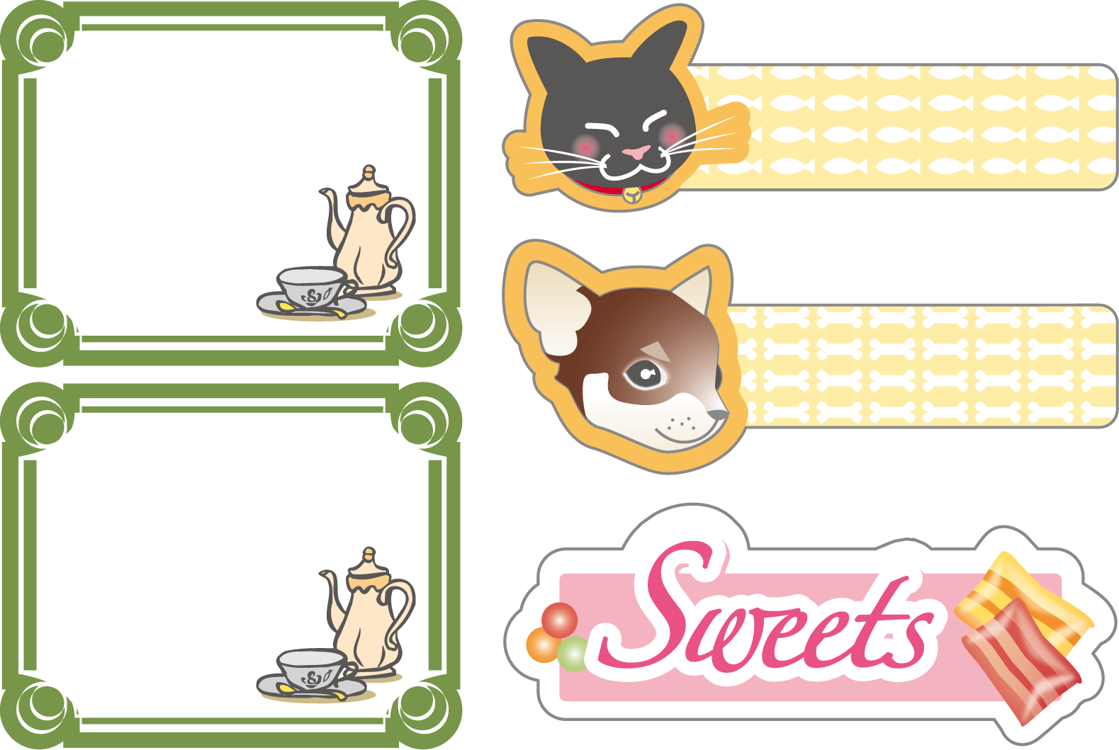
Homemade
cookie
Tel:0123-456-789
Thank you
for purchasing it
Homemade
cookie
Tel:0123-456-789
Thank you
for purchasing it
クロのエサ
ショコラのエサ

